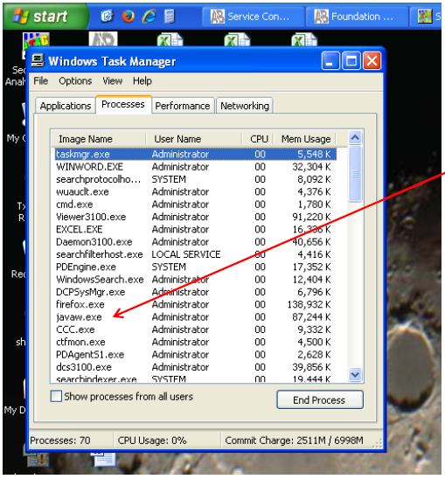
- If the program SequenceAnalysis disappears after starting the program and inputting the password (*******), hit “Ctrl-Alt-Del” to open the Task Manager, find the process “javaw.exe” (not, “java.exe”), and end it.
- Then reopen SequenceAnalysis, which will generate the Error message below. Select “Delete existing lockfile” (might require multiple clicks) and the program should open normally.

