Tips for using the E-gel system
- Do not exceed the capacity (~ 1 ug) of each well in terms of mass; samples streak if you overload the well.
- Prior to running samples on the E-gel, clean them with a column (e.g., Zymo DNA Clean & Concentrator-5 Kit; Cat #: 11-303).
  - Generally, PCR mixes are not supposed to interfere with migration; however, high salt PCR buffers can affect migration... and samples should at least be diluted if the expected salt concentration is over 50 mM NaCl, 100 mM KCl, or 10 mM EDTA.
  - We found the Maxime PCR Premix Kit (Intron Biotech) caused smaller DNA fragments to migrate faster than expected in the E-gel, leading to a long tail of small fragments to the left of the main DNA peak when visualized on the Bioanalyzer DNA-HS chip (see below)... and subsequently to an excess of shorter than desired reads when sequenced on the Ion Torrent PGM.
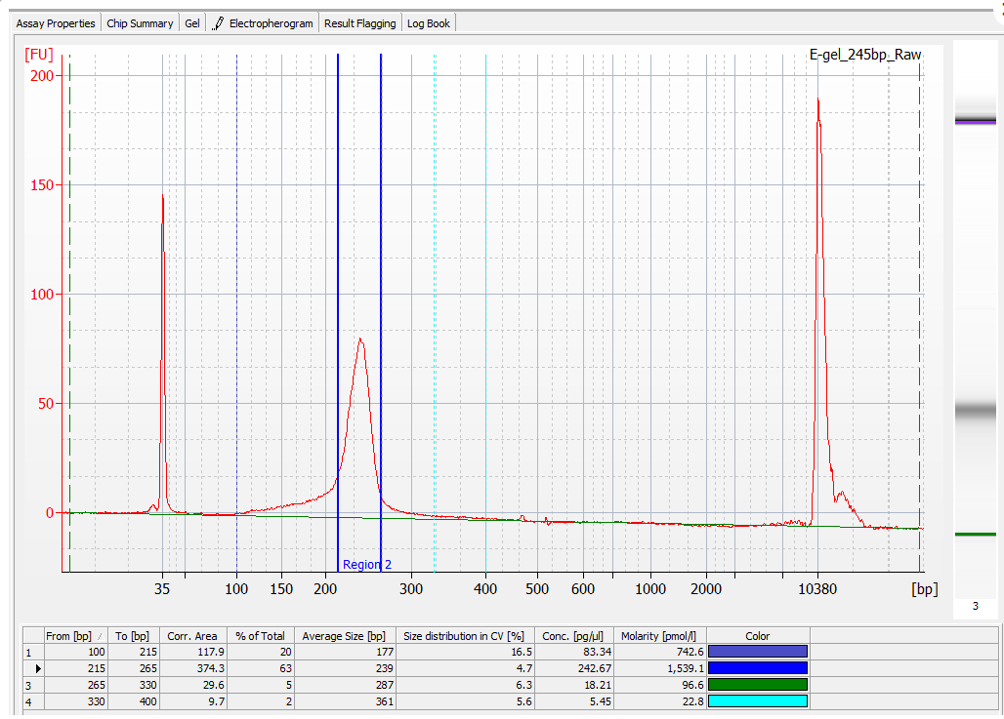
- DNA Ladder:
  - Use a good ladder; we found the NEB Quick-Load Purple 2-Log DNA Ladder to be a good choice. It's best to aliquot the ladder so it does not degrade from freeze/thaw cycles.
  - The ladder can be diluted in Low TE or Water for most samples (rather than 20 mM NaCl). High salt can cause smearing and poor migration. The key is to match the salt concentration of your samples, so you might even add PCR buffer (if your samples are still in PCR buffer) if it did not break the salt concentrations of Tip #2.
  - While the DNA marker is intended to be in the middle well, you can load marker in the other wells if you are not using all other wells for samples. This can help with sizing if there is any 'smile' effect in the gel.
  - The 50-bp DNA ladder (Invitrogen Cat. no. 10416-014) stock concentration is 0.5 ug/ul; however, the assay calls for only 100-250 ng in the marker well.
    - Thus, for each single ul of the stock DNA marker, add sufficient suitable buffer to generate a working stock of ~17.5 ng/ul... and 10 ul of that working stock will deliver ~175 ng of DNA marker... with enough total volume for 5-6 gels.
    - However, the DNA marker might not be very stable at such a low concentration; thus, you might want to freeze aliquots at an intermediate dilution (perhaps somewhere between 100 and 250 ng/ul) which can be kept in the refrigerator (after the first thawing) and used to make smaller amounts of the fully-diluted working stock.
- Be sure to fill ALL empty wells with water any time you are running the current. It's a high current system, and you want uniform flow across the gel for the best migration. It's unlikely that you will need to re-fill the loading wells during the run, but it would not hurt if you think that evaporation may have occurred.
- Migration times can vary due to temperature and age of the gels. Always watch the gel for the last minute or two to make sure you stop at the right moment. You can lose the ladder band in the collection wells if you are not paying attention.
- You CAN run the gels in reverse if you overshoot your target.
- Loading dyes can cause the DNA to migrate at the incorrect molecular weight. This is true of all gels. Because E-gels are rapid gels, some shifts can be more dramatic than what you may see with traditional agarose migration. However, the bigger issue is the dye can mask the bands, which makes it difficult to see your material.
- Stop the gel briefly when the desired band (or region) approaches the collection wells.
    - Remove as much of the "salty" fluid as practical from the collection well (discarding the fluid, unless you wish to save that fraction of DNA as a precaution);
    - Fill the collection wells with fresh nuclease-free water (~20 ul) and pipette lightly to mix;
    - Remove most of the liquid from the collection well (discarding the fluid); and,
    - Re-fill collection wells with fresh nuclease-free water (~20 ul).
- Restart the gel, running it until the desired band (or region) is in the collection well; typically, this will be marked by having the appropriate ladder bands spanning their collection well; however, judgment calls are needed for situations in which the ladder bands do not closely match the desired fragment sizes, excessive ‘gel smiling’ occurs, or collection wells are not immediately adjacent to the ladder(s).
- Remove the fluid in the collection well and store it in a clean tube (preferably a product such as an Eppendorf Lo-Bind tube).
  - Avoid pulling up agarose (which can inhibit downstream reactions) from the bottom of the collection well; instead of trying to get to the bottom of the well, pull from near the surface... which gets most of the buffer.
  - For maximum recovery, re-fill the collection tube with nuclease-free water, lightly pipette, and collect the ‘rinse’ solution as well.
- You can collect multiple fractions from the same well; running the fractions in a Bioanalyzer DNA-HS chip will show the fragment size distribution (as well as concentration) of each fraction.
- If you plan to analyze the collected fractions on the Agilent BioAnalyzer DNA-HS chip, clean the collected samples first by a column (e.g., Zymo DNA Clean & Concentrator-5 Kit; Cat #: 11-303).
  - Tests using ‘blanks’ from E-gels demonstrated that, without a column-cleaning step, components inherent to the E-gel could adversely affect the function of the DNA-HS chip; whereas, if samples were cleaned first, the chips functioned normally even with real samples that were size-selected by the E-gel system.
  - Above all, do NOT concentrate the samples by simply reducing the volume (e.g., by a SpeedVac system). In testing of Speed-Vac’d samples, results from DNA-HS chips were grossly distorted (wells #5 & #6 were always affected; #4 was often affected; and #11 was sometimes affected), even when the vacuum-concentrated E-gel samples were not run in those particular wells.

